Arham Khan
22k-4080 BAI-6B
CN ASSIGNMENT 1
Submitted to: Sir Usman

Proxy Server Setup (ZeroOmega Extension):
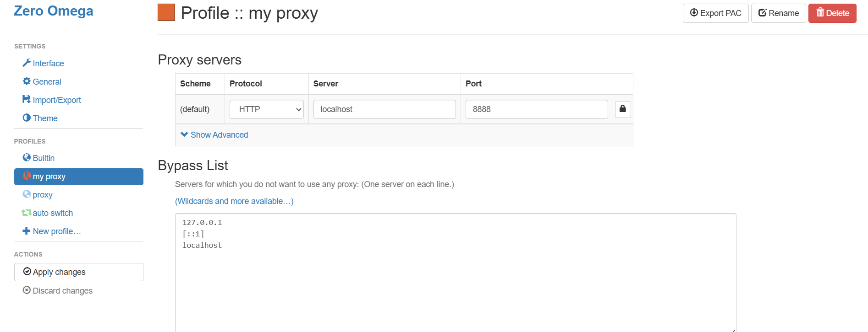
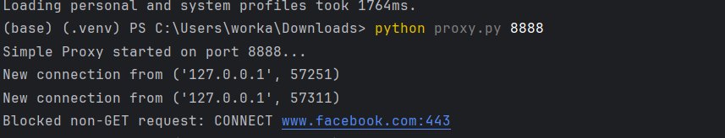
Port 8080 was busy.

HTTP GET Request working perfectly:
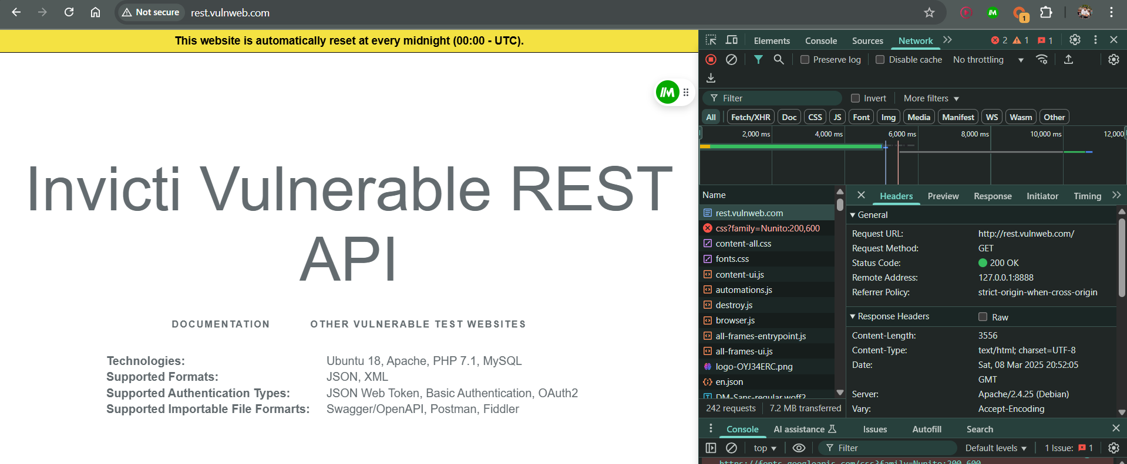

HTTP Request other than GET Method (Not working):
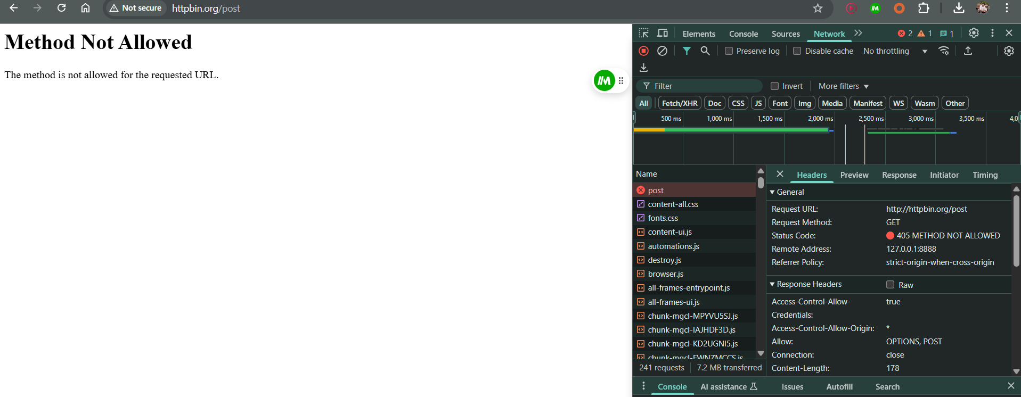
Testing using Curl:
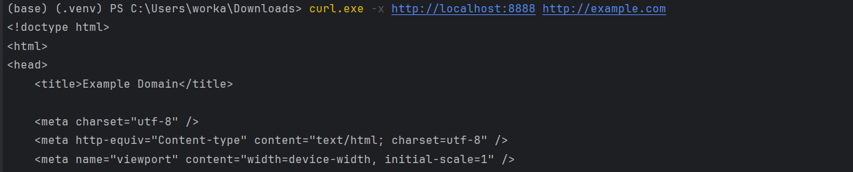

Code:
import sys
import socket as sk
import threading
def http_client(client_socket):
request = client_socket.recv(1024) #receiving data in small chunks
if not request:
client_socket.close()
return
# Split request into lines
headers = request.decode().split('\r\n')
if not headers:
client_socket.send(b'HTTP/1.0 400 Bad Request\r\n\r\n')
client_socket.close()
return
first_line = headers[0].split()
if len(first_line) < 3:
client_socket.send(b'HTTP/1.0 400 Bad Request\r\n\r\n')
client_socket.close()
return
method, full_url, _ = first_line
if method != 'GET':
print(f"Blocked non-GET request: {method} {full_url}")
client_socket.send(b'HTTP/1.0 501 Not Implemented\r\n\r\n')
client_socket.close()
return
# splitting url
if not full_url.startswith('http://'):
client_socket.send(b'HTTP/1.0 400 Bad Request\r\n\r\n')
client_socket.close()
return
clean_url = full_url[7:]
server_part = clean_url.split('/', 1)
host_port = server_part[0].split(':', 1)
target_host = host_port[0]
target_port = int(host_port[1]) if len(host_port) > 1 else 80
path = '/' + server_part[1] if len(server_part) > 1 else '/'
# Connecting to target server
server_socket = sk.socket()
if server_socket.connect_ex((target_host, target_port)) != 0:
client_socket.send(b'HTTP/1.0 502 Bad Gateway\r\n\r\n')
client_socket.close()
return
# Forward request
server_socket.send(f"GET {path} HTTP/1.0\r\nHost: {target_host}\r\n\r\n".encode())
# Relay response
response = server_socket.recv(4096)
while response:
client_socket.send(response)
response = server_socket.recv(4096)
# Cleanup
server_socket.close()
client_socket.close()
def myproxy_server(port):
server = sk.socket(sk.AF_INET, sk.SOCK_STREAM)
server.setsockopt(sk.SOL_SOCKET, sk.SO_REUSEADDR, 1)
server.bind(('', port))
server.listen(10)
print(f"Simple Proxy started on port {port}...")
while True:
client_socket, addr = server.accept()
threading.Thread(target=http_client, args=(client_socket,)).start()
if __name__ == "__main__":
if len(sys.argv) != 2:
print("Usage: python proxy.py <PORT>")
sys.exit()
myproxy_server(int(sys.argv[1]))

